Software Requirements Specification
for
Chess is Pain

Prepared by Condor Army

02/02/2018
Table of Contents
Table of Contents ii
1. Introduction 1
1.1 Purpose 1
1.2 Intended Audience and Reading Suggestions 1
1.3 Product Scope 1
1.4 Definitions 1
1.5 References 2
2. Overall Description 2
2.1 Product Perspective 2
2.2 Product Functions 2
2.3 User Classes and Characteristics 2
2.4 Assumptions and Dependencies 2
3. External Interface Requirements 3
3.1 User Interfaces 3
3.2 Hardware Interfaces 4
4. System Features 4
4.1 System Start Menu 4
4.2 System Settings Screen 5
4.3 User Movement 6
4.4 Core Game Screen 7

Introduction

Purpose
This Software Requirements Specification Document (SRS) is intended to describe the requirements needed to implement and design the game application (chess). This SRS covers the full chess application and all features that will be implemented within the user interface.

Intended Audience and Reading Suggestions
This document is intended towards our customer (Jason Diaz), documentation writers, testers, and developers of the game. This document contains an overview of the chess application, as well as requirements for the user interface and functional requirements to implement into the Software Design Description. The intended way to read this SRS is to read through the introduction and overall description sections first (sections 1 and 2). Documentation writers should then look through the external interface requirements and system features (sections 3 and 4) to look through functional requirements to set up a Software Design Description document or Test Plan. Developers should first look to these aforementioned documents during the coding phase but should refer to this document if further explanation is required for a certain requirement.

Product Scope
Chess shall use a user interface to allow a user to engage in a real time game of chess against the computer. This game shall begin from the normal starting position and complete when a checkmate has been determined. This program shall also include bonus features including sound effects, highlighting movement options, a random move generator in which the game will make the move for the player, a countdown timer giving the player a time limit in which to make a move (move timer), and allowing the user to choose a board and piece color of the player’s choice.

Definitions
Move timer – A countdown timer showing how much time the user must move.

User – Someone who interacts with the chess game application.

Chess – The game application this document covers.

SRS – This Software Requirements Specification document.

References
How to play Chess: Rules and Basics. (n.d.). Retrieved February 13, 2018, from
https://www.chess.com/learn-how-to-play-chess
Ostler, J. (2002, May 2). History of Chess. Retrieved February 13, 2018, from
http://www.chess.com/blog/jim_ostler/history-of-chess12

Overall Description

Product Perspective
Chess is a two-player board game said to have originated in the 6th century AD in India (Ostler, 2002). The game consists of the players taking turns moving their pieces (designated by color) according to specific rules determined by the type of piece being moved. As the pieces move they can “capture” an opponent’s piece by landing on top of it. The game ends whenever either of the players’ king goes into “checkmate”, meaning there is no way to stop it from being captured in the next opponents turn, at which point the opposing player wins the game. You can find a full list of the rules of chess in the references section (1.5) of this SRS (“How to play Chess: Rules and Basics”). This chess application will have movement options of all pieces according to this ruleset and will recreate the board in a 3-D environment with a computer taking the place of a human opponent.

Product Functions
- Allow for user input
- Include sound effect
- Highlighting movement options
- Random move maker
- Move timer
- Board Color choice
- Piece Color Choice

User Classes and Characteristics
This chess program is intended for users of all ages who have a basic understanding of chess and its rules. All users will have same privileges within the chess application, and all requirements will pertain to every user.

Assumptions and Dependencies
This program can be played in any system that can run Unity 2017.3 and Java version

External Interface Requirements

User Interfaces
The software shall present the user with a main menu with options to play, change the settings, or quit the game.

Figure 1: System Start Menu

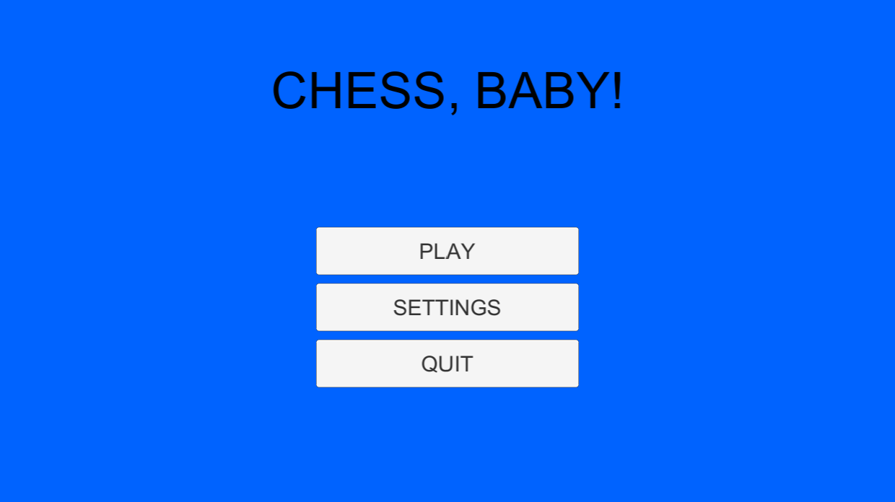

Figure 1: Shows the system start menu which shall allow the user to make desired settings as well as begging and exiting the game.

Figure 2: User Settings
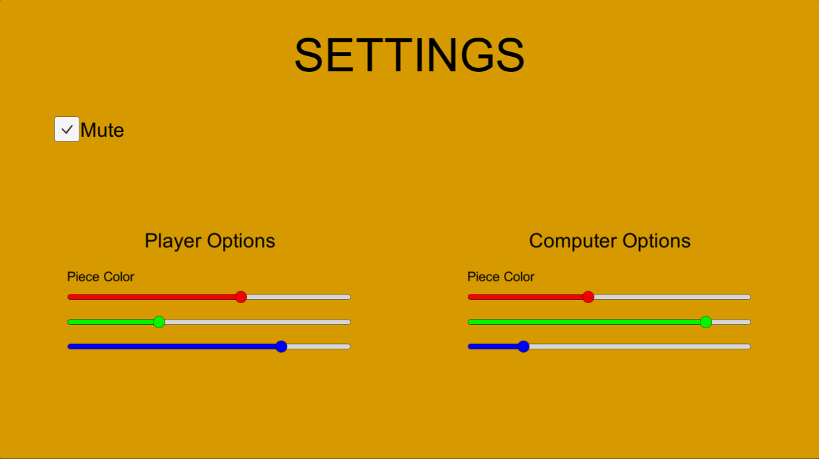

Timer

Figure 2: Shows User setting whish shall allow the user to personalize the game.

Figure 3: Game Screen
Time left: 20:00
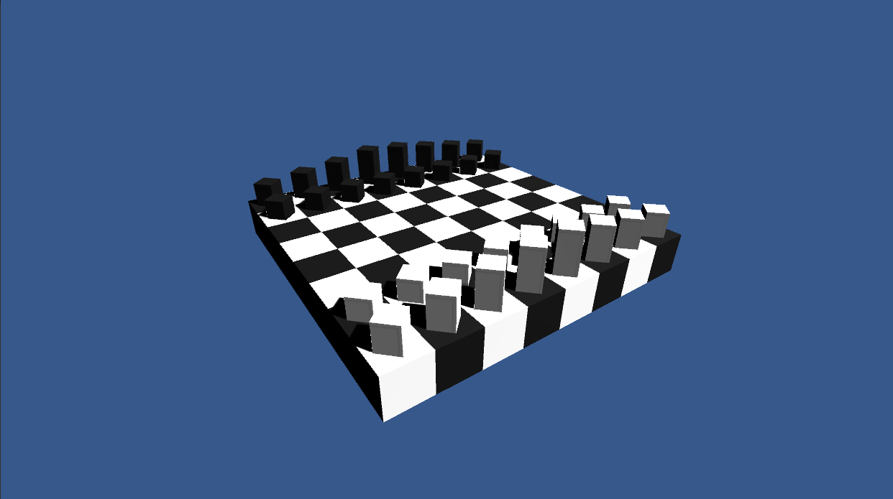
Figure 3: Shows the screen that users will see when playing the game.

Hardware Interfaces
The system shall accept inputs from no fewer devices than a keyboard and mouse.

System Features

System Start Menu

Description

When the application is executed, the user is presented with a start screen. The screen will allow the user to choose to either start the game with the start button, change settings for the game with the settings button, or quit the game with the quit button, which will automatically close the chess application. If no user input is given towards the settings, starting the game will default to the user going first as well as the user being white and the computer being black, the board being white and black, timer being disabled. After the user has given their desired settings, they may click the start button to game screen.

Stimulus/Response Sequences
Step 1: Launch Chess Game application in windows
Step 2: User updates any desired settings within the settings screen. (optional)
Step 3: User clicks the start button and is transferred to the game screen.

Functional Requirements

REQ-1: The system shall allow the user to start the game by clicking on the start button, transferring the user to the game screen.
REQ-2: The system shall allow the user to update their settings by clicking on the settings button, transferring them to the settings screen.
REQ-3: The System shall allow the user to quit the game from the system start screen by pressing on the quit button, closing the application.

System Settings Screen

Description and Priority
The settings screen will allow the user to choose the board and piece color for the user and computer, as well as deciding who will goes first, and if they want to mute game sound. If they want a move timer they should also be able to decide the amount of time or default to 20 minutes. If no user input is given towards the settings, the chess game will default to the user going first as well as the user being white and the computer being black, the board being white and black, timer being disabled, and game sound being active. After the user has given their desired settings, they may click the on a button to go back to the system start screen.

Stimulus/Response Sequences
Step 1: System displays the settings screen displaying setting options.
Step 2: User decides upon desired settings to apply to their chess game.
Step 3: User returns to system start menu through back button.

Functional Requirements
REQ-1: The system shall allow the user to choose the color of their own pieces and of the computers.
REQ-2: The system shall allow the user to choose the color of board.
REQ-3: The system shall allow the user to choose who will go first or if the selection is random.
REQ-4: The system shall allow the user to disable/enable to move timer.
REQ-5: The system shall allow the user to mute/unmute game sound.
REQ-5: If the timer is enabled, the system shall allow the user to input desired time.
REQ-6: The system shall default the start screen to have the user play first and to be white, the computer to be black with a disabled timer, game sound to be unmuted, and the board to be black and white.
REQ-7: The system shall allow the user to return to the system start menu at any time.

User Movement

Description and Priority
Once it is the users turn to move, the user will be able to select any of their pieces at which point any possible moves will be highlighted on the board. The user will be able to choose from these highlighted spaces at which point the piece will move from its current position to the selected position, making a sound in the process and ending the users turn. They user may instead choose the random move option which randomly moves one piece to a random legal available position. If the user does not make a valid move before the move timer runs out, the users turn will automatically end and it will become the computers turn.

Stimulus/Response Sequences
Step 1: The timer will start the countdown from the desired time if move timer is enabled.
Step 2: The user will be able to select a piece of their own.
Step 3: The system will highlight any valid available positions.
Step 4: The user can choose a highlighted position to move that piece to or can choose a different piece going back to step 3.
Step 5: If the user does not want to make a movement of their own, they can choose the random move generator to make the decision for them.
Step 6: The user has either picked a move or the timer has run out. Either way the users turn will end.

Functional Requirements

REQ-1: The system shall allow the user to choose a piece of their own to move.
REQ-2: The system shall highlight movement options when a piece is selected.
REQ-3: The system shall allow the user to make a random move of their own piece if desired.
REQ-4: The system shall make a noise or sound whenever a piece is moved or on an invalid move.
REQ-5: If the timer reaches zero, the system shall automatically end user’s turn starting computer’s turn.

Core Game Screen

Description and Priority
Once the game has started, the screen will display a chess board with desired board color options and chess pieces of desired colors in its normal starting position. The screen will also display a timer if enabled and its desired time starting at the beginning of each players turn, as well as display a random move option but only during the users turn.

Stimulus/Response Sequences
Step 1: System has either computer or user starts the game depending on previously decided settings.
Step 2: User can make random move at any point during their turn.

Functional Requirements
REQ-1: The system shall indicate who’s turn it is according to the settings.
REQ-2: The system shall start the move timer if enabled at the start of each players turn.
REQ-3: The system will display the random move option only during users turn.
REQ-4: The system shall display the chess board.

